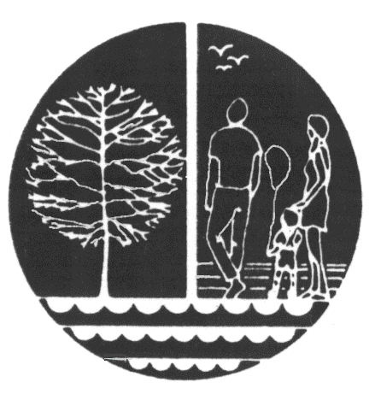**Western Rio Blanco**

**Recreation & Park District**

611 South Stanolind Avenue, Rangely, CO 81648

Tel: (970) 675-8211 Fax: (970) 675-8011 Web: www.wrbmrecreation.org

July 7, 2025

**Attention**

Western Rio Blanco Metropolitan Recreation & Park District Residents and All who attended the 4th of July Show this year at the Reservoir.

I would like to point out some people who give of their time and efforts each year voluntarily to help put on the 4th of July Fireworks show and without them it would be impossible to do the show that we do each year. The following are to be commended and if you see them out and about please thank them for their service as I can’t thank them enough and felt this was a good way to get them recognized as they do not seek the **credit**, they SERVE the community in which they love and care for!!

Todd Lowe, Travis LeBleu, Kyle Wren, Jeff Fielder, Andy Shaffer, Richard Brannan, Charlie Lowe, Keenan LeBleu, Rangely Rural Fire Protection District, Rio Blanco County Sheriff’s Department, Rangely Police Department, Rio Blanco Conservancy District.

If you see these folks out and about tell them THANK YOU!!!